**Gaminfinity SDK**

**Programming Guide**

V2.2.0.0

*for*

Eclipse(Android)

Xcode(iOS)

Unity(Android/iOS)

Release History

|  |  |  |
| --- | --- | --- |
| Version | Date | Description |
| V1.2.4 | 2014-09-30 | First release in English Version |
| V1.2.5 | 2014-10-22 | Change Facebook Login Sample: Force Facebook Login as WebView Login |
| V2.0.0.0 | 2014-11-19 | Add SDK for Unity  Remove content about Facebook programming example. |
| V2.1.0.0 | 2014-11-20 | Add a new requirement that Game developer must mark an account ID with Facebook user ID in data base when login by Facebook account, in order to indicate which account ID is login by Facebook account or login by guest (Play Now) |
| V2.2.0.0 | 2014-12-16 | Add a new requirement that the PlayNow Button must avoid double click(multiple touch at the same time) in Chapter 9-2 Requirement 2 |

**Table of Content**

1. Introduction 5

2. Gaminfinity SDK API 6

2.1 getAccountId 6

3. Gaminfinity SDK Sequence Diagram 8

3-1 Play Now 8

3-2 Facebook Login 9

3-3 Self-Test 9

4. Example for Eclipse(Android) 11

4-1 information 11

4-2 Steps 11

4-3 Calling Gaminfinity SDK API 12

5. Example for Xcode(iOS) 13

5-1 information 13

5-2 Steps 13

5-3 Calling Gaminfinity SDK API 14

6. Example for Unity(Android/iOS) 15

6-1 information 15

6-2 Steps 15

6-3 Calling Gaminfinity SDK API 19

7. Download Site 20

7-1 Gaminfinity SDK for Android 20

7-2 Gaminfinity SDK Demo for Android 20

7-3 Gaminfinity SDK for iOS 20

7-4 Gaminfinity SDK Demo for iOS 20

7-5 Gaminfinity SDK for Unity 20

8. Configurations 21

8-1 Configuration for Self-Test 21

8-2 Configuration for Testing 21

8-3 Configuration for Live 21

9. Requirements 22

9-1 Requirement 1 22

10. Appendix 23

10-1 Error Code Definition 23

# Introduction

This document describes how to use Gaminfinity SDK to get unique ID from Gaminfinity SDK server to identify a user.

The number of API in Gaminfinity SDK is one.

The platforms supported by Gaminfinity SDK are Android and iOS, and there are three Gaminfinity SDK types for different development tools, they are Eclipse for Android, Xcode for iOS, and Unity for Android/iOS.

The basic concept of using Gaminfinity SDK can be as simple as the following steps:

(1)Import Gaminfinity SDK to your project

(2)Creates an instance of the Gaminfinity SDK and initialize it.

(3)Setup a callback function to retrieve unique id from Gaminfinity SDK.

(4)Calls the Gaminfinity SDK API, getAccountId, when user is trying to login, and the unique ID will be returned to the callback function in step 3.

Note:

(1)Before initializing Gaminfinity SDK，please get Gaminfinity SDK Server URL ready. Because Gaminfinity SDK Server URL may have different value, please contact Gaminfinity technical support for the correct URL value.

(2)It is recommended to be familiar with how to use Facebook SDK to retrieve Facebook authorized access token, for the access token will be used as an input parameter in Gaminfinity SDK.

# 2. Gaminfinity SDK API

## 2.1 getAccountId

**Purpose**

Acquire a unique ID to identify a user.

**Input Parameters**

String accessToken //Facebook access token

String url //Gaminfinity SDK Server URL

accessToken: null or valid Facebook access token

url: null or Gaminfinity SDK Server URL

**Parameter options**

There are two options to preform login: (1) Play Now (or Guest Login), (2) Facebook Login

|  |  |  |  |  |
| --- | --- | --- | --- | --- |
| # | Options | accessToken | url | Description |
| 1.1 | Play Now | NULL | NULL | Retrieve a fixed value equals to “A123456789”, only for self-test mode |
| 1.2 | Valid URL | Retrieve a user ID |
| 2.1 | Facebook Login | access token | NULL | Retrieve a fixed value equals to “A123456789”, only for self-test mode |
| 2.2 | access token | Valid URL | Retrieve a user ID |

Callback function

void onGetAccountId(int result, String accountId)

**Return Values**

int result

When result = 1，success.

When result = -n, something goes wrong, please refer to Appendix for error code definition

String accountId //user ID

# Gaminfinity SDK Sequence Diagram

There are three sequence diagrams for different cases:

(1) Play Now, or Guest Login,

(2) Facebook Login,

(3) Self-Test (for test purpose only)

In each sequence diagram, there are maximum five roles:

1. Game Client：A game app runs on user device
2. Facebook SDK：The SDK provided by Facebook
3. Gaminfinity SDK：The SDK provided by Gaminfinity
4. Gaminfinity Server: the server which provides service to Gaminfinity SDK
5. Facebook： Servers owned by Facebook

## 3-1 Play Now

When a user touches【Play Now】button

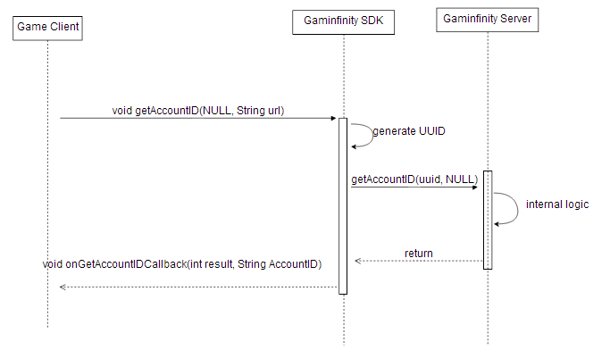

## 3-2 Facebook Login

When a user touches【Facebook Login】button

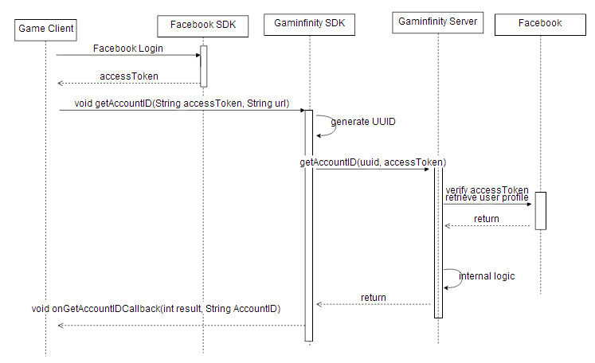

## 3-3 Self-Test

The purpose of Self-Test is to make sure the Gaminfinity SDK is loaded to your game project successfully and can be called properly.

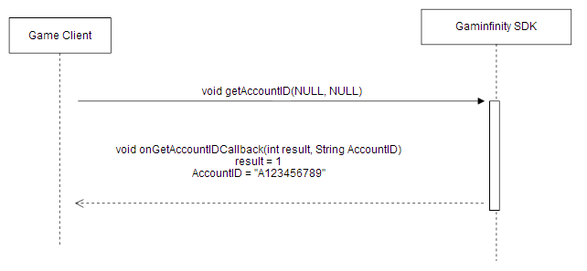

# Example for Eclipse(Android)

## 4-1 information

Development tools: Android SDK ADT: adt-bundle-windows-x86-20140624

Gaminfinity SDK file name：GaminfinitySDK-vx.x.x.x.jar

## 4-2 Steps

1. import Gaminfinity SDK package to your project
2. extends Activity with Gaminfinity SDK interface
3. declare a variable of ClientSDK
4. create a ClientSDK instance
5. implement Gaminfinity SDK interface

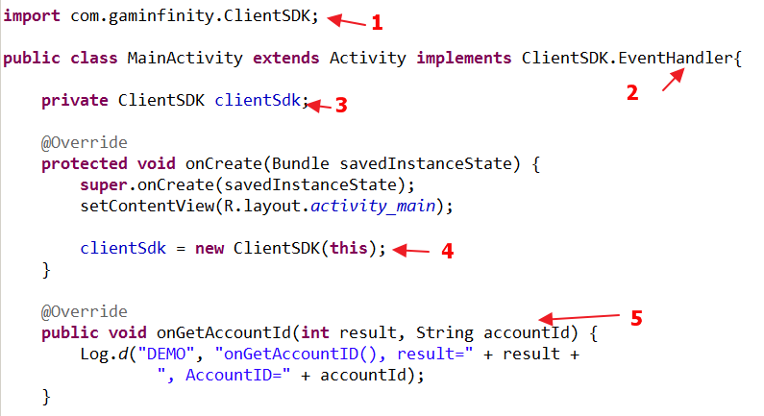

## 4-3 Calling Gaminfinity SDK API

(1) Play Now

clientSdk.getAccountId(null, "http://GaminfinityServerURL");

Note：

accessToken should be null

url: please contact technical support for valid URL

(2) Facebook Login

clientSdk.getAccountId("Facebook accessToken", "http:// GaminfinityServerURL");

Note：

accessToken should be valid Facebook access token

url: please contact technical support for valid URL

# Example for Xcode(iOS)

## 5-1 information

Development tools：Xcode 5.1.1

Gaminfinity SDK file name：libGaminfinitySDK.a and GaminfinitySDK.h

## 5-2 Steps

1. Using Gaminfinity SDK include file

#import "GaminfinitySDK/GaminfinitySDK.h"

1. Extends Gaminfinity SDK Interface

@interface ViewController : UIViewController **<EventHandler>**

1. declare a variable of ClientSDK

GaminfinitySDK* gaminfinitySdk;

1. create a ClientSDK instance

gaminfinitySdk = [[GaminfinitySDK alloc]init];

gaminfinitySdk.delegate = self;

1. implement Gaminfinity SDK interface

- (void) onGetAccountId:(int)result AccountId:(NSString *)accountId{

…

}

## 5-3 Calling Gaminfinity SDK API

(1) Play Now

[gaminfinitySdk getAccountId:nil ServerUrl: @"http://GaminfinityServerURL"];

Note：

accessToken should be null

url: please refer to Configurations for valid URL

(2) Facebook Login

[gaminfinitySdk getAccountId:fbAccessToken ServerUrl: @"http:// GaminfinityServerURL"];

Note：

accessToken should be valid Facebook access token

url: please refer to Configurations for valid URL

# Example for Unity(Android/iOS)

## 6-1 information

Development tools：Unity 4.5.5 Free Version

Gaminfinity SDK file name：GaminfinitySdk4Unity.unitypackage

The Gaminfinity SDK for Unity is based on the Gaminfinity SDK for Android and Gaminfinity SDK for iOS, which is a wrapper package for Unity.

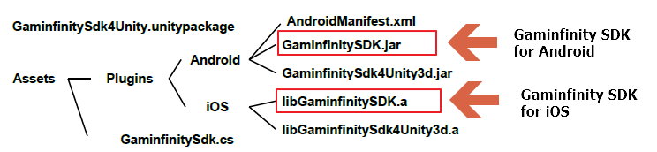

## 6-2 Steps

(1)Download the GaminfinitySdk4Unity.unitypackage

(2)Open Unity3D and create a new project

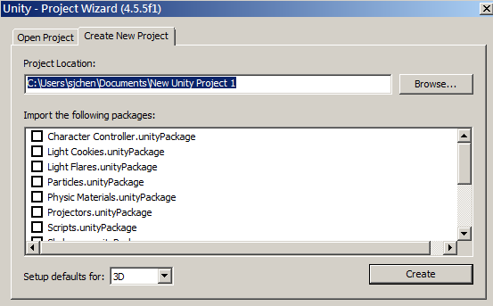

(3)Import GaminfinitySdk4Unity.unitypackage to your new project

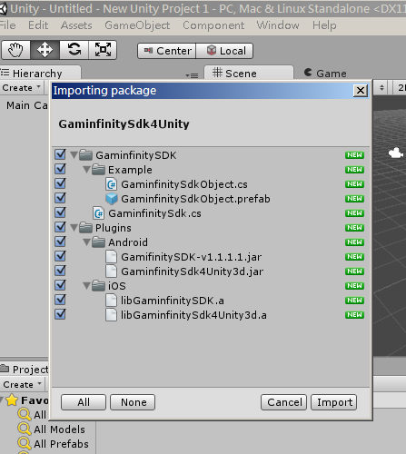

(4)Drag and drop the GaminfinitySdkObject.prefab(in the path of Assets\GaminfinitySDK\Example) to your scene.

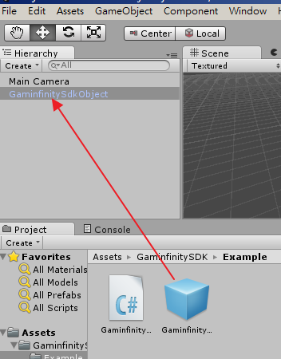

(5)Configure necessary settings in the Build Settings

For example, set up your bundle name, choose target device…, etc.

Connect your target device to your computer

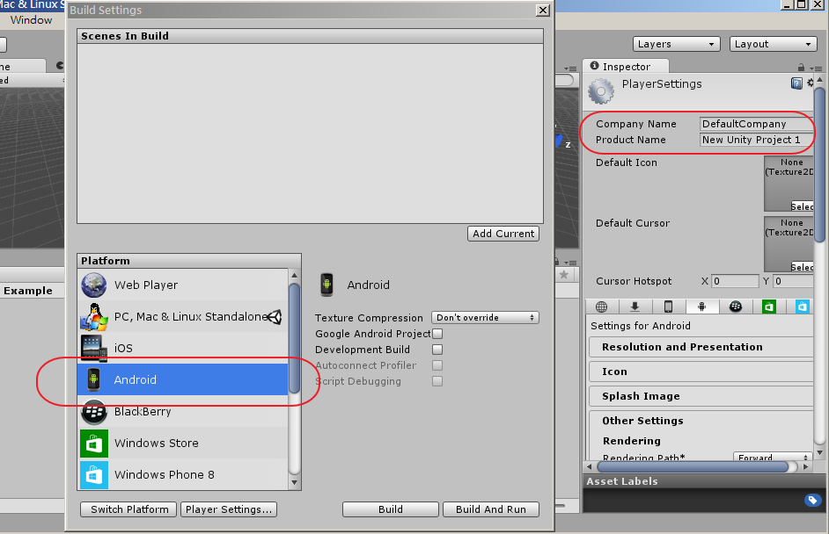

(6)Build and Run

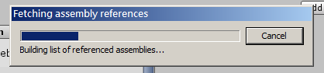

(6)Click the button and get data from Gaminfinity SDK server

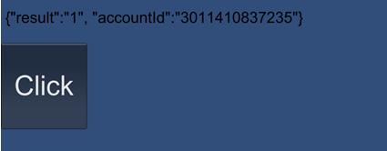

Once calling the method GaminfinitySdk.getAccountId (accessToken, url), the data will be returned and placed to the method name: void onGetAccountId(string msg) in the game object “GaminfinitySdkObject”

Please note that the name of game object to retrieve data from Gaminfinity SDK server must be “GaminfinitySdkObject”, because the name is used by the internal callback object name in the Gaminfinity SDK.

## 6-3 Calling Gaminfinity SDK API

(1) Play Now

GaminfinitySdk.getAccountId (null, "http://GaminfinityServerURL");

Note：

accessToken should be null

url: please refer to Configurations for valid URL

(2) Facebook Login

GaminfinitySdk.getAccountId ("Facebook accessToken", "http:// GaminfinityServerURL");

Note：

accessToken should be valid Facebook access token

url: please contact technical support for valid URL

# Download Site

## 7-1 Gaminfinity SDK for Android

<https://github.com/stevechen0923/GaminfinitySDK/tree/master/Android/>

## 7-2 Gaminfinity SDK Demo for Android

https://github.com/stevechen0923/GaminfinitySdkDemo/tree/master/Android

## 7-3 Gaminfinity SDK for iOS

<https://github.com/stevechen0923/GaminfinitySDK/tree/master/iOS>

## 7-4 Gaminfinity SDK Demo for iOS

https://github.com/stevechen0923/GaminfinitySdkDemo/tree/master/iOS

## 7-5 Gaminfinity SDK for Unity

<https://github.com/stevechen0923/GaminfinitySdk4Unity3d>

# Configurations

## 8-1 Configuration for Self-Test

The purpose of Self-Test is to make sure the Gaminfinity SDK is loaded to your game project and can be called properly.

In this mode, there is no need internet access because no connection to Gaminfinity Server，

Please note that this mode is only for development phase.

Gaminfinity Server URL = NULL

## 8-2 Configuration for Testing

Gaminfinity SDK connects to Testing Gaminfinity Server for developing and testing purpose.

Gaminfinity Server URL = <http://60.199.161.41/sns/new_bind_uuid.php>

## 8-3 Configuration for Live

Gaminfinity SDK connects to Live Gaminfinity Server

Please note app on app store should use this configuration.

Gaminfinity Server URL = Please contact technical support team for correct url

# Requirements

## 9-1 Requirement 1

Game developer must mark an account ID with Facebook user ID in data base when login by Facebook account, in order to indicate which account ID is login by Facebook account or login by guest (Play Now)

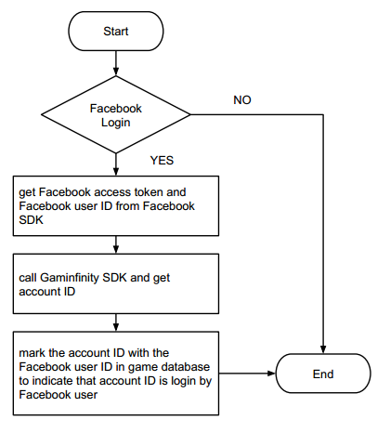

## 9-2 Requirement 2

Game client must avoid the PlayNow button to be double-clicked, in order not to call SDK API (getAccountId) multiple times at the same time. The API getAccountId can be called again only when the result of calling getAccountId has been returned.

# Appendix

## 10-1 Error Code Definition

1 Success

**Error code from Gaminfinity Server**

-1 parameter error

-2 invalid Facebook Access Token

-3 Facebook binding error

-99 Server internal Error

**Error code from Gaminfinity SDK**

-100 general error(including network error)

-101 server connection timeout(timeout=10 seconds)

-102 network disconnected

-103 network transport error

-104 data encryption/decryption error

-110 Internal Error